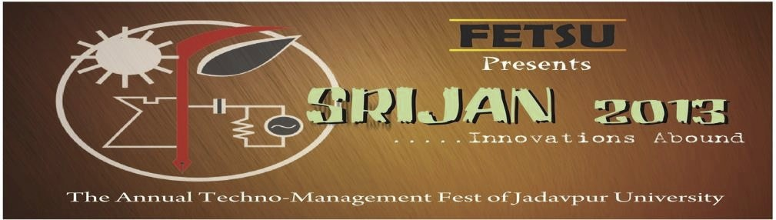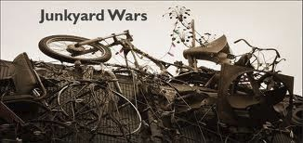

Junkyard Wars

Imagine you and your three friends are the sole survivors of a plane crash on an island. You   
have nowhere to go and no hope of being rescued. You find that the island was once   
inhabited and due to some mysterious reason it is now in a post -apocalyptic state. All that   
remain is a large junk of seemingly useless materials. But you guys have to survive, even in   
such a treacherous climate. You have to fend for yourself and have to use your wit and   
imagination to innovate.

The task is to convert the useless junk into to something wonderful and usable. As the saying goes, nothing is useless.

Welcome to Junkyard Wars people!!!

General Rules:



The maximum number of participants in a team is 4.

Each member must produce a valid ID card of his/her respective institution. However students from different institutions can form a team.

Event Specific Rules:

1>Anyone found using an electronic device(mobiles etc) will be disqualified. 2> Only the materials provided should be used for construction.   
3> Participants found taking external help will be disqualified.   
4> The participants have to complete their tasks within the specified time. 5> The decision of the judges will be final and binding.

Event Details:

The event will take place in two Rounds :

1> Round 1 is the elimination round. It will comprise of a written exam testing the basic concepts of physics and mathematics and general aptitude.

2> Round 2 is the real deal. Some basic junk materials will be provided to the participants and

within a specified time a working model has to be constructed using only those materials. The exact model to be constructed will be told on spot.

For more information’s contact:

Sankhanil Goswami Archisman Biswas

9433666808 8981630988

sankhanil@gmail.com